 | 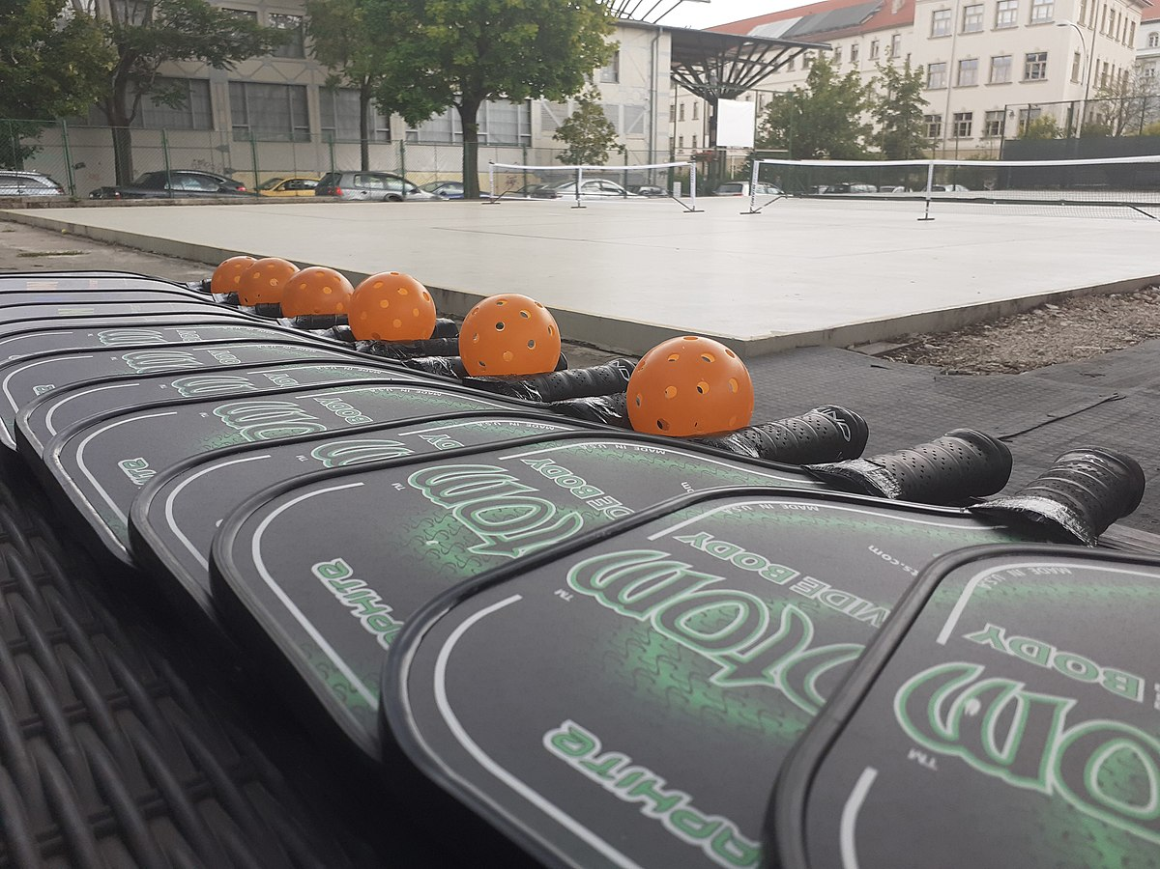 | PICKLEBALL OPEN PLAY  JULY 2022  Punchcard Fee/KH Fee: $40/$35  Walk-IN Fee/KH Free: $5/$4
 | Morning | Evening
MON
TU
WED
TH
FRI | 8:15 – 9:30 am  *No Open Play July 29th
SUN |  | July 10th & 17th  3:30 – 5:30 pm
www.thecommunityhouse.org, 415 W. Eighth St., Hinsdale, IL 60521, PH: 630-323-7500

